What is happening?
- Luminist is replacing the local copy of Document Direct as of Monday, May 2, 2016
- The link below will direct the customer to the GTA landing page that will contain help / information / adobe reader / zip file app / associated information to assist in searching and printing reports from TeamWorks
https://ebill.ga.gov/

What do agencies need to do?
- To launch Luminist, go to: https://ebill.ga.gov/luminist/index.jsp#
- A default repository will need to be set up
  - On top right click the wheel – a drop down will be displayed to choose the repository, for the purposes of this example we are using INFOSSG, yours may be different.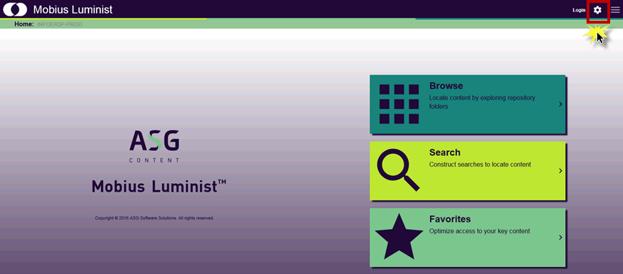
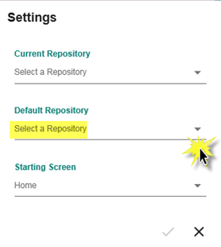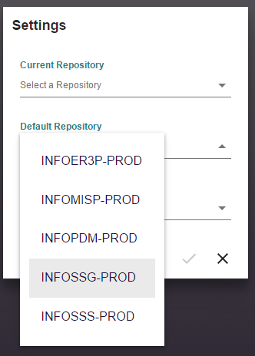

- Click the check at the bottom of the popup page
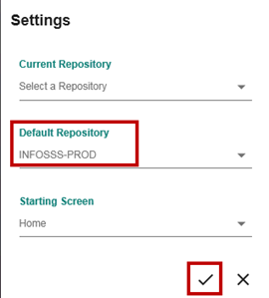

- Note the selected default repository will now display at the top left

How do I launch and access Luminist?

- Click login located top right

- Popup window – enter userid/password – click login

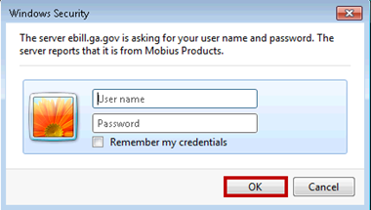

- Click on dark green browse button to locate reports

How do I locate reports in Luminist?
- On left side – the Browse: INFOSSG-PROD/INFOMISP-PROD should appear
- On left side – the Reports folder should be visible
- Click on Reports folder

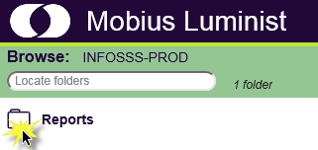

The following examples/screenshots are from the INFOSTT repository in the TEST environment, but all repositories in production work exactly the same.

- Enter 2 digit module + 3 digit BU (GLXXX) in the Locate Folder field to locate report by module
- Select report
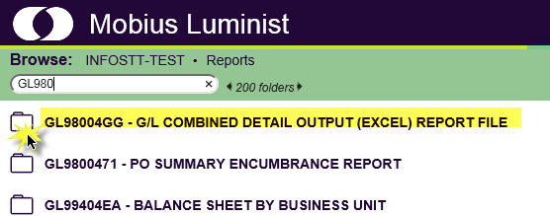

- The versions (report run date) of the report will be displayed
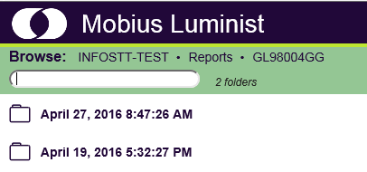
- Choose a version – if you receive a 500 error – the report has been archived ...click again it should display in a few secs/mins, as it has to retrieve it from the archived location.
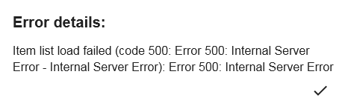

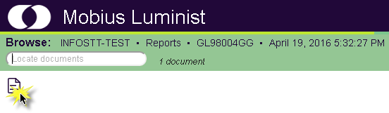

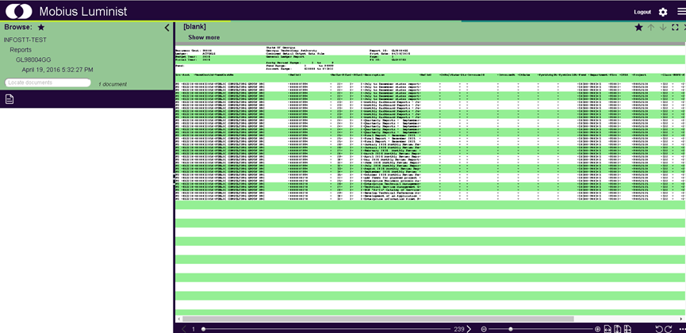

How do I run the GG report and download it to Excel?
- On top left a piece of paper icon displays – highlight this area
  - Beside are several options – choose View
  - There report displays on right side of screen
  - On the piece of paper icon on left side – highlight and choose extract and filter
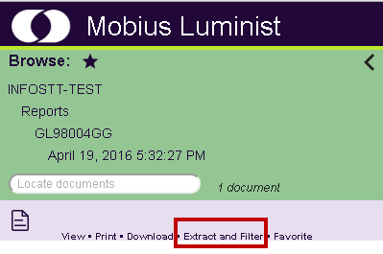
  - On the left side – the Policy GL46704GG is displayed
  - Highlight and click apply rule
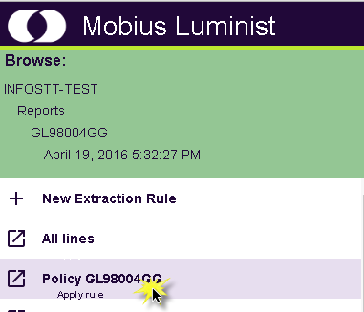

  - On right side of screen the report displays but is in a different format.
  - At top right click down arrow
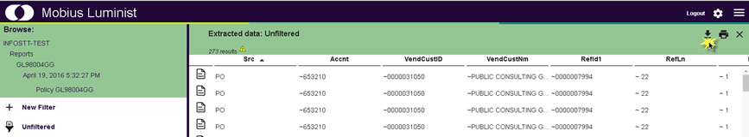
  - Popup box will appear – download – will list group/format/file name – keep as is for now…and click down arrow
  - The csv file will be downloaded in zip format – if a zip product is needed we have a recommendation listed on the Luminist landing test website listed at top of email
  - Click on the file – it may say open / save as…but mostly open file

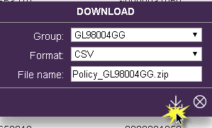

  - A popup window will appear with the name of the csv file

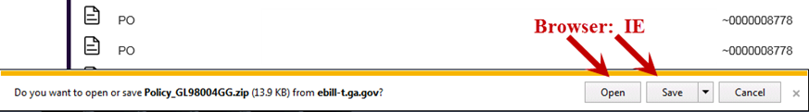

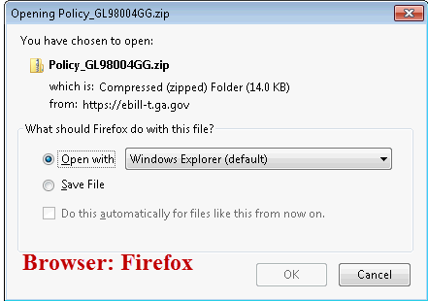
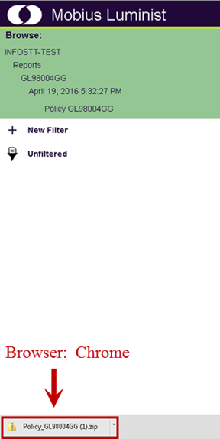

  - Click on the file name or open/save – the file will appear in Excel ready to be utilized where needed

